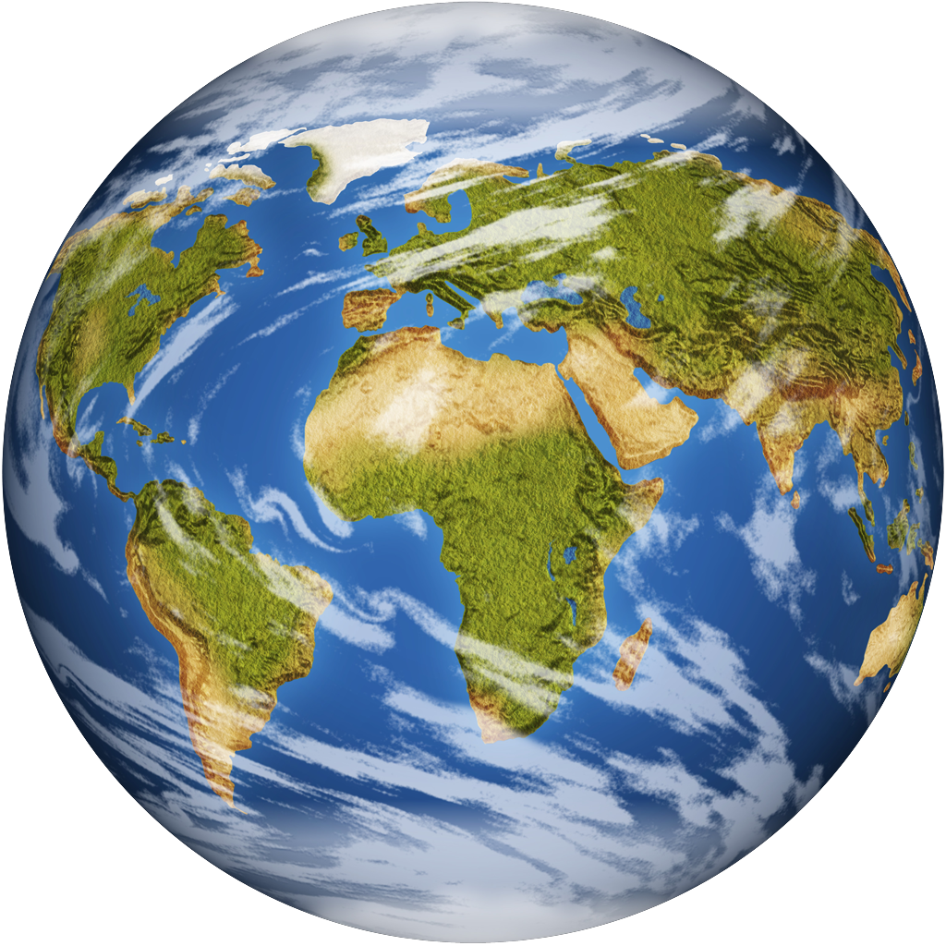
Name: ___________________________________ Date: _______________
Current Events Report

Title of Article: ______________________________________________________

Source:______________________________________________________________

Article Date: _____________________________

Circle One: Local State National World

Who was involved?
__________________________________________________________________________________________________________________________

Where did this article happen? (Be specific) __________________________________________________________________________________________________________________________

When did the event happen? (Date, month, time frame, and/or year) _____________________________________________________________

What happened? (Include important details in at least five complete sentences) ____________________________________________________________________________________________________________________________________________________________________________________________________________________________________________________
__________________________________________________________________________________________________________________________
__________________________________________________________________________________________________________________________
____________________________________________________________________________________________________________________________________________________________________________________________________________________________________________________
_____________________________________________________________

_____________________________________________________________
__________________________________________________________________________________________________________________________
_____________________________________________________________
__________________________________________________________________________________________________________________________

What is your personal response? In at least five sentences, address one or more of these areas: why you chose the article, why the information is important, what you found interesting, how you feel about it, what action you think should be taken, what you would do to solve the problem, any questions you were wondering, any connections you made, etc.

____________________________________________________________________________________________________________________________________________________________________________________________________________________________________________________
__________________________________________________________________________________________________________________________
__________________________________________________________________________________________________________________________
_____________________________________________________________
_____________________________________________________________
_____________________________________________________________
__________________________________________________________________________________________________________________________

